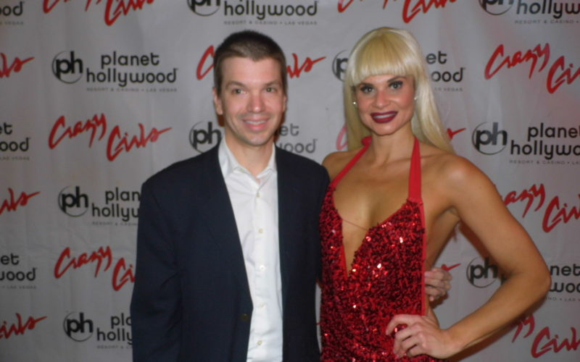

The Talented Dani Elizabeth: Host with the Most of Crazy Girls Talks Role in Longest Running Burlesque Show in America, More
By Chris Yandek in CY CELEBRITIES CY INTERVIEWS CY NEWS CY WHAT'S HAPPENING December 27, 2018
Growing up in a small town in upstate New York, Dani Elizabeth always knew she wanted to be in show business. Eventually, she made her dream a reality. After a job ended in California, she applied to be part of the cast of a long running Las Vegas show called Jubilee. The show was a showgirl extravaganza that ended production in 2015 after more than 30 years.
Then came a part-time job with the longest running burlesque show in America, Crazy Girls, which has been on the Las Vegas Strip for 31 years. Dani seems to have a proclivity for shows with longevity. And any show would be lucky to have her. The part-time gig turned into full-time role and now she is the host of one of the most historic shows in Las Vegas. We recently shared with you our show report on CYInterview [see here] of Crazy Girls when we attended a few weeks back.
As the host of this well-known topless revue, Dani Elizabeth is hilarious, quick witted and can belt out a tune. Her opening act in the show takes you back to vintage Las Vegas. Besides being the voice of this historic burlesque show, she also takes part in some of the dance routines by herself and with the other women. See our photo above with her.
When you go see Crazy Girls at the Planet Hollywood Hotel and Casino and watch her perform throughout the show, this is what she wants you to know about her:
“I hope that my performance always shows this, but I want people to know how much I love it and how grateful I am to be doing it because I know that it’s a gift to be able to walk up on a stage and get paid to do that. At least in my eyes I think it’s a gift and I won’t always be able to do it and there are people out there that are dying to do it and don’t have the opportunity that I have been granted with. So I think I want people to realize that every time I go up there I give 110 percent and I hope that people just enjoy and know how much I really do love it, how grateful I am that people want to come and see us because without an audience there is no show.”
Dani Elizabeth also revealed to us how she stays in shape for this sexy show, talks to us about her dance background, as well as many other topics. We sat down with her for this CYInterview after the recent Crazy Girls show we attended at the Sin City Theatre, where the show is performed, inside the Planet Hollywood Hotel and Casino.

Listen to the entire Dani Elizabeth CYInterview:

http://www.cyinterview.com/the-talented-dani-elizabeth-host-with-the-most-of-crazy-girls-talks-role-in-longest-running-burlesque-show-in-america-more/

