Las Vegas Sun

Photos: ‘Crazy Girls’ at Riviera marks 25 years — butt with new look
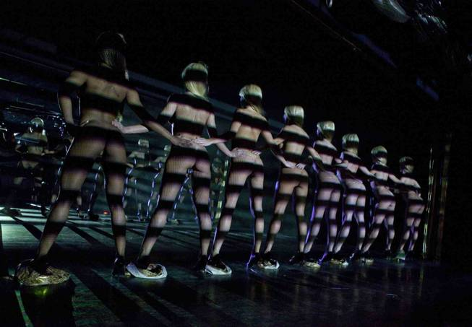
CRAZY GIRLS
“Crazy Girls” at the Riviera.
By Robin Leach
Tuesday, Jan. 10, 2012 | 2:03 p.m.

More arts and entertainment
- Check out Robin Leach's VegasDeLuxe.com for more celebrity and A&E coverage, including more photo galleries of "Crazy Girls."

'Crazy Girls' at the Riviera
The iconic and now-legendary “butt” bronze sculpture of the gorgeous “Crazy Girls” outside the Riviera will remain, but to celebrate the show’s 25th year, new ”butt”-posed photographs of the eight topless temptresses will be used in the 2012 marketing campaign on posters and promotions.
Since the butt bronze has been on the Strip, tourists and locals have rubbed the sculpture for good luck before playing in the casino hotel. Photographs of the butt image have gone around the world, and it has become as famous as the Welcome to Fabulous Las Vegas sign.
“We’ve got a much bigger ‘wow’ factor in place for our 25th anniversary year,” company manager Jennifer told me. “New dancers, new numbers, new routines and new outfits. Our song ”Girls Run the World” sums it up well. Today the dancers are more technical, so they are able to do more extension and point work. That adds to the sexcitement with the show.”
“Crazy Girls” will celebrate the 25th milestone all year long with surprises each week and a big party in June. “The brass statue might stay the same, but in the new butt photos, we have all different girls in smaller strings and different wigs!” she laughed.
Jennifer explained why “Crazy Girls” says it’s the Strip’s favorite topless show after a quarter century: “We have constantly updated. We were the first. We were the original, and everybody else has been a copy.
“We added singers. We have Whitney and her understudy Rachel for songs. Whitney performs the opening and another later number with Rachel on country. We always have eight of the sexiest girls in the show, with seven available for rotation -- and even I can fill in when necessary.
“We also abide by the no-fishnets rule. It makes it harder to recruit dancers, but the au naturel adds to the success of the show. Most shows in Vegas pretty much have the dancers wear fishnets. The girls are trained with their bodies because we are closer to the audiences. You can’t hide them in fishnets like a lot of other shows.
“We don’t wear big showgirl costumes. We’re about small costumes -- the smaller, the better. We get out there and really interact with the audience. The dancers keep their bodies beautiful, unblemished and in top shape.
“Since the hotel has had new owners, we’ve been working on many new ideas. We also opened a Crazy Girls Pleasure Pit. It has six blackjack tables and two poles for different girls to dance on weekends. They wear our signature colors with hot pink bra tops and black booty shorts for their pole tricks, which are all different than the show’s girls. It only takes a month for a girl to learn the pole tricks, but for the show, you have to come with a lot of dance experience and passion for the profession. Really trained dancers from a young age. That’s what sets us apart, makes us different and successful for so long.”
Lead lineup lovely is Las Vegas’ own Summer, who has been a part of the show for six years and is in charge when Jennifer is away. “We are on a constant search for talented dancers and girls,” Jennifer said. “A lot of girls look good but can’t dance or can dance but don’t look great. It’s become harder today to compete with nightclubs because girls will make more money as a go-go dancer than they would being in a show. Being in the show, though, really shows their love to perform professionally onstage as a bona-fide Vegas showgirl.”
Las Vegas producer Norbert Aleman created “Crazy Girls,” and he’s still in charge today. “I am proud with what we brought to the Strip back then as the first. I am very proud we are still here, and 25 years later, that’s a major accomplishment and recognition of great dancing and entertainment,” he said.
Robin Leach has been a journalist for more than 50 years and has spent the past decade giving readers the inside scoop on Las Vegas, the world’s premier platinum playground.
Follow Robin Leach on Twitter at Twitter.com/Robin_Leach.
Follow Vegas DeLuxe on Twitter at Twitter.com/vegasdeluxe.
Follow VDLX Editor Don Chareunsy on Twitter at Twitter.com/VDLXEditorDon.

